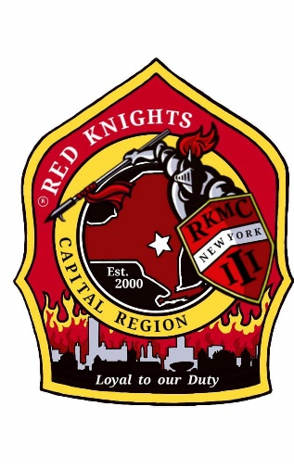
Red Knights
Motorcycle club
New York Chapter III – Capital Region, NY

Date of meeting – February 13, 2025

Place of meeting – Club House, NYRVFA
- Meeting called to order by President Pat O’Connor at 7:07 pm.
- Pledge of allegiance lead by Ray Hazzard.
- Moment of silence by Pat.
- Prayer –prayer by chaplain Deb Landy.
- Attendance and roll call: 22 members and 2 guests.

Membership: Tony, Ray, Larry – Application for Active membership for Michael Lang, sponsored by Pat O’Connor. Motion to accept Michael made by Paul, 2nd by Mike. Motion passed.
Secretary - Motion made to dispense the reading of the minutes made by Kenny, 2nd by Casey. Motion Passed.
Secretary Report: – Deb Landy – no report.
Treasurer’s Report: - Jim Alexander –

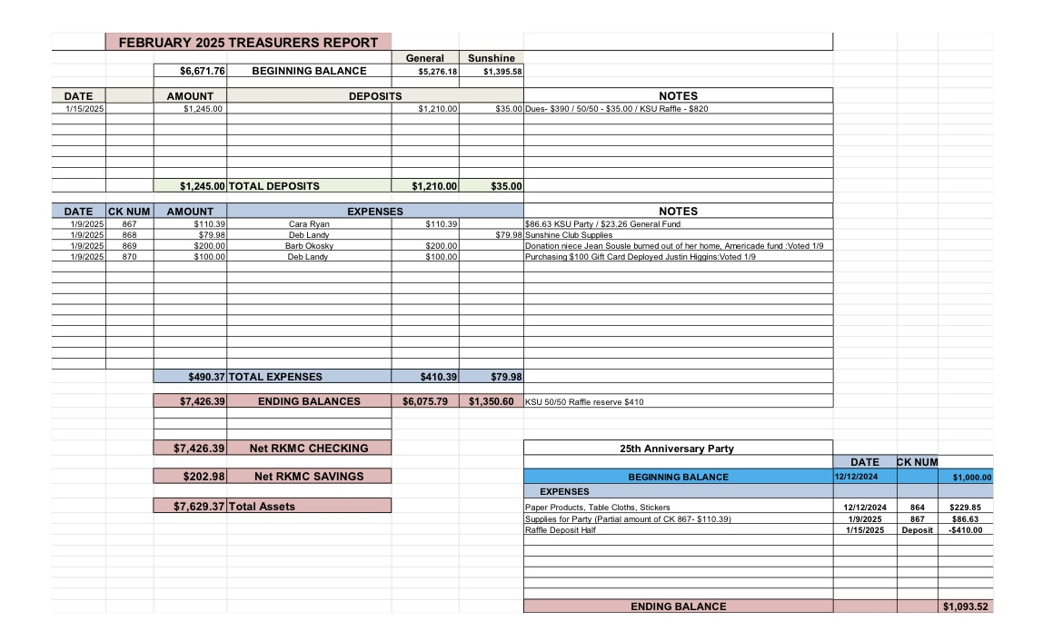

Motion made by Mary to accept the treasurer’s report, 2nd by Morgan. Motion passed.

Vice President – Larry Gates – There was a firefighter fatality at a fire in Binghamton. Please keep them in your prayers.

President Report – Pat O’Connor – Pat attended a couple of meetings for rides. The schedule will be forwarded once completed. Pat recently forwarded a few emails from International.

Appointed Officers:

Chaplain – Deb Landy – Pat is still looking for an assistant chaplain. Please contact Pat if you’re interested.

Information Officer– Matt Mickle – Matt spends tons of time working on the web site. He has added more photo galleries. There are tons of photos, check them out! Please post any ride and event photos to our Facebook Page so that Matt can put them on the web site. If you want anything posted on the website, get it to Matt. The price from our hosting service went up 40%. Matt continues to look at another service for a better price. He requires unlimited space as we have tons of stuff. The password for members only is n3WyorkIII.

Sergeant at Arms: Ray and Mike M. – no report.

Quartermaster: Nate, Pat, Tony, Eddie, Jeaninne, Linda - no report.

Ride Captain(s): Don Asst RC, Tony – Kevin resigned as Ride Captain. Nominations for ride captain are being accepted. Jodi has offered to collect the nominations. Please email Jodi at jodi.gittodavis@gmail.com. There was a meeting last week to put together a ride schedule. It will be forwarded when it is ready.

Committee Reports:

Abate/PAC – Casey – no report.

Audit and Finance - Don, Larry, Andrea – this needs to be scheduled.

America’s 9/11 Ride – Kevin, Donna, Ernie, Pat, Larry, and Cara –This is the 24th anniversary of 9/11 and the 25th anniversary of the ride. The ride is 8/15 – 8/17. Registration for the 2025 ride is open. ww.americas911ride.org

AMERICADE Committee – Don G, Larry, Tony, Calvin C, Ray, Jim, Kris (food), Matt (Advertising/Artwork) – Don is working on the ride route. The ride will be Wednesday May 28th, 2025.

NON- AMERICADE Committee – Larry, Matt, Ray and Kenny – camping is planned for June 17 – 22, 2025.

Grievance Committee – Ray, Mike M., Deb and Jodi - no report.

International Convention Committee –Deb and Eddie - Peoria, Illinois 8/21 – 8/24, 2025. See Facebook for details.

Kick Stands Up Party Committee – Cara, Tony, Kris, Donna, Mary, Deb, Andrea, Cimber, Mick, Linda, and Tina. - Kick Stands Up Chrome Edition – Celebrating 25 years of NY III . Some shopping has been done for decorations and table settings. Matt is creating an invitation. We need to know who many from the chapter along with their guests will be going by March 1st so we know how many other guests from outside the chapter we can have. The room holds a maximum of 120 people, so it is important that you RSVP.

Meeting Room Committee – Cara, Matt, Andrea, and Casey – no report.

Memory Tree Committee – Deb, Cara, Jodi, Pat, Donna, and Andrea – no report.

Military Committee – Bob & Linda Dennett, Jeannine, Kimber – Linda announced that Morgan Gates has joined the Army National Guard. She leaves for bootcamp on April 1st and after will study sonar operating support, Cyber Security. We collected $350 to send to Justin Higgins. The package sent to him had the items we collected and 3 packages of Death Wish Coffee, Justin’s favorite. Cimber sent out 4 packages to deployed service members and included cards from our chapter. Patrick Root is doing well and is currently deployed.

Nickname Patch Committee – Pat, Eddie, Deb, Tony, and Ray – Pat has collected the submitted suggestions. Nicknames submission form is on our website or contact a committee member to submit your suggestion. Keep them coming.

NY III Family Picnic – Barb O’Kosty and Kris –2025 picnic will be at Barb O’Kosky’s house on 8/9 at 241 Pruyn Hill Rd, Mechanicville.

Safety Committee - Casey – Riding season is right around the corner, get ready.

SOGs - Matt, Mike M, Lori – no report.

Sunshine Club –Deb, Cara, and Andrea – 1 card was sent. Morgan Gates joined the Army National Guard and her fire house.

RITA Walk – “Out of the Darkness” – Linda & Nancy – 9/28/2025.

YANKEE RALLY 2024 –Kenny – Next year is Bangor, ME. June 4 – 9, 2025. See their Facebook page for details.

Ways & Means - Craig, Matt, Bill, Calvin and Casey –50/50 raffle to fund the KSU – Chrome Edition Party. 1200 of the 2000 tickets have been turned into Matt. As of tonight, a total of $4275 has been collected, the winner gets $2137.50. Let’s sell out of tickets.

Old Business: no report

New Business:

Larry made a motion to donate $200 to the Barss family. Derrick Barss is a Saratoga Springs Firefighter. The son, Ayden, is having sever lung issues and is in Albany Med. 2nd by Matt. Motion passed.

Deb asked for reimbursement of $134.82 for KSU decorations. Motion to reimburse Deb made by Mike, 2nd by Casey. Motion passed.

Paul made a motion to be reimbursed $46.45 for KSU decorations. 2nd by Matt. Motion passed.

Cara made a motion to be reimbursed $207.86 for KSU supplies. 2nd by Matt. Motion passed.

Good and Welfare –

Cimber has tickets for the Tsatsawassa Fire house for a Blackstone Grill. They are $5 each or 5 tickets for $20.

3/1 – Shaker Rd Firehouse Comedy show. See Facebook for details and tickets.

2025 is the 59th year of Shaker Rd – Loudenville explore post. There will be events throughout the year.

50-50 - $38 to the chapter and $37 to the winner. Congratulations Larry.

Motion to adjourn meeting at 8:09 made by Tina, 2nd by Kenny. Motion passed.

Website Members Only Password - n3WyorkIII

OUR NEXT MEETING WILL BE THURSDAY, March 13TH AT THE CLUBHOUSE.

