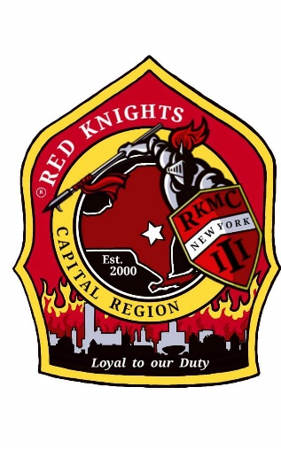
Red Knights
Motorcycle club
New York Chapter III – Capital Region, NY

Date of meeting – March 13, 2025

Place of meeting – Club House, NYRVFA
- Meeting called to order by President Pat O’Connor at 7:08 pm.
- Pledge of allegiance lead by Ray Hazzard.
- Moment of silence by Pat.
- Prayer –prayer by chaplain Deb Landy.
- Attendance and roll call: 26 members.

Membership: Tony, Ray, Larry – Application for Active membership for John Rucinski Jr, sponsored by Pat O’Connor. Motion to accept John made by Mick, 2nd by Barb. Motion passed. John is a Life Member of International and does not pay International dues. Motion to wave chapter dues made by Kenny, 2nd by Barb. Motion passed.
Secretary - Motion made to dispense the reading of the minutes made by Barb, 2nd by Mary. Motion Passed.
Secretary Report: – Deb Landy – no report.
Treasurer’s Report: - Jim Alexander –

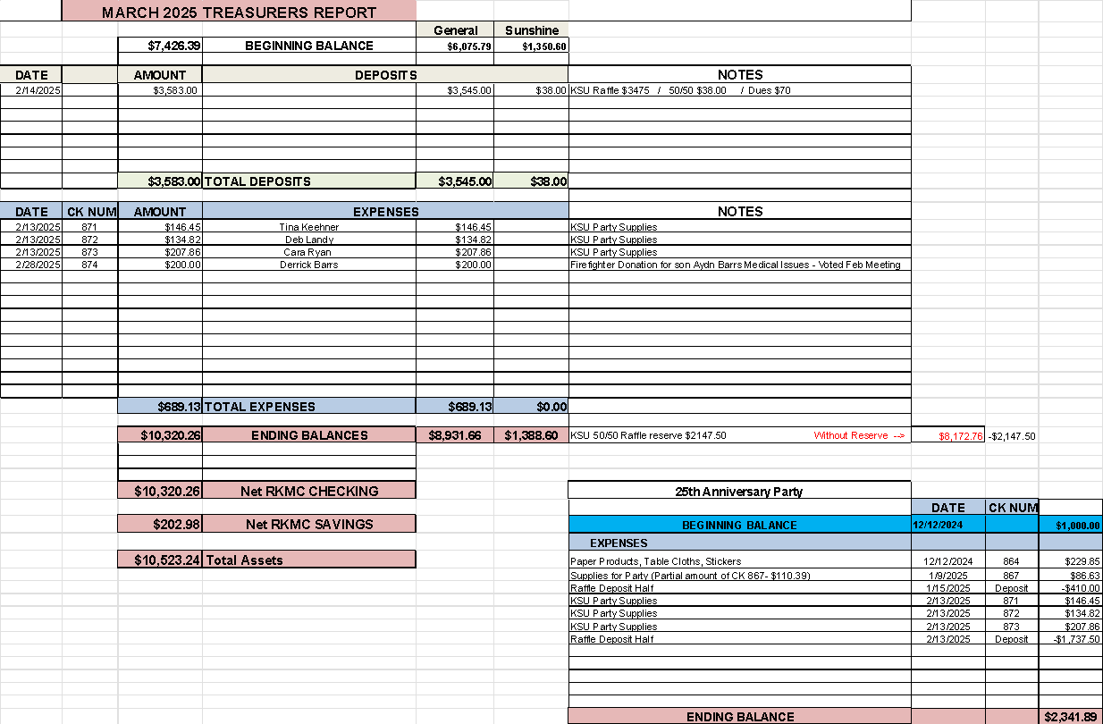

Motion made by Paul O. to accept the treasurer’s report, 2nd by Morgan. Jeaninne passed.

Vice President – Larry Gates – Sunday 3/23 1-6pm, ride and support for a little girl, Lilly, who has cancer. Meeting in Galway and ride to Wally’s Driftwood Park in Gloversville. Details will be posted.

President Report – Pat O’Connor – Pat was invited by Tim Tordoff to go with him to Binghamton NY 6. They were on the news to promote their chapter’s bowling benefit. NY 6 is a small chapter and was looking for support and help in growing their chapter. Pat asked John R to contact the chapter to help them with growing and rebuilding the chapter. Patt also reminded us as we get our bike out that other drivers are not used to seeing them on the roads and that the potholes are huge as we had a real winter this year.

Appointed Officers:

Chaplain – Deb Landy – Pat is still looking for an assistant chaplain. Please contact Pat if you’re interested.

Information Officer– Matt Mickle – Matt spends tons of time working on the web site. There are tons of photos, check them out! Please post any ride and event photos to our Facebook Page so that Matt can put them on the web site. If you want anything posted on the website, get it to Matt. The price from our hosting service went up 40%. It seems they are the only ones with unlimited space and he requires unlimited space as we have tons of stuff. The password for members only is n3WyorkIII.

Sergeant at Arms: Ray and Mike M. – no report.

Quartermaster: Nate, Pat, Tony, Eddie, Jeaninne, Linda – Nate asked if the members want to do a rerun of the S.K.O.F.U. shirts from last year or a sweatshirt or job shirt or fall jackets. See Nate with ideas and requests.

Ride Captain(s): Don Asst RC, Tony – Kevin resigned as Ride Captain. Nominations for ride captain are being accepted. Jodi has offered to collect the nominations, no nominations were received so far. Please email Jodi at jodi.gittodavis@gmail.com. The ride schedule was sent out. The first ride of the season is NY 53’s bike blessing on May 3rd.

Committee Reports:

Abate/PAC – Casey – no report.

Audit and Finance - Don, Larry, Andrea – this needs to be scheduled soon.

America’s 9/11 Ride – Kevin, Donna, Ernie, Pat, Larry, and Cara –This is the 24th anniversary of 9/11 and the 25th anniversary of the ride. The ride is 8/15 – 8/17. Registration for the 2025 ride is open. ww.americas911ride.org. Money is being raised. Matt is working on a flyer and Lisa McCabe has a letter for distribution.

AMERICADE Committee – Don G, Larry, Tony, Calvin C, Ray, Jim, Kris (food), Matt (Advertising/Artwork) – Don – The ride is approximately 140 miles thru covered bridges. Lunch will be in Bennington. Registration will be at the Lake George fire house. Pat will ask NY 11 to help set up for morning registration. The ride will be Wednesday May 28th, 2025.

NON- AMERICADE Committee – Larry, Matt, Ray and Kenny – camping is planned for June 17 – 22, 2025. Several other chapters are planning on coming. Larry asked if they want Playing With Fire Band to play again with the campers paying for half and the campsite paying for the other half. The members who are planning to go agreed to pay for the band. Saturday night will be a group BBQ again with everyone attending pitching in for the meat and buns or bringing a dish. They may be able to borrow Dave Demarco’s large smoke grill for Saturday night.

Grievance Committee – Ray, Mike M., Deb and Jodi – Pat needs to stop picking on Kenny now that he has new hearing aids and can hear the comments.

International Convention Committee –Deb and Eddie - Peoria, Illinois 8/21 – 8/24, 2025. See Facebook for details.

Kick Stands Up Party Committee – Cara, Tony, Kris, Donna, Mary, Deb, Andrea, Cimber, Mick, Linda, and Tina. - Kick Stands Up Chrome Edition – Celebrating 25 years of NY III . The event is on 4/19 at 5pm. Party décor is being collected. Pat is working on a special project. Matt has created an invitation. The movie of NY III will be played throughout the evening and then will be posted to our website after the event. 50 from our chapter have RSVP’d so far. Some of the food items from the planned menu are still needed. Please contact Cara at 518-330-3084 if you plan to attend and have not yet RSVP’d. Other chapter members will now be invited.

Meeting Room Committee – Cara, Matt, Andrea, and Casey – no report.

Memory Tree Committee – Deb, Cara, Jodi, Pat, Donna, and Andrea – no report.

Military Committee – Bob & Linda Dennett, Jeannine, Kimber –Justin Higgins should be home by the end of the month. Morgan Gates goes to basic training for the Army Reserve on April 1st. Patrick Root is doing well and is currently deployed.

Nickname Patch Committee – Pat, Eddie, Deb, Tony, and Ray – Pat has collected the submitted suggestions. Nicknames submission form is on our website or contact a committee member to submit your suggestion. Nick Names will be presented at the KSU party.

NY III Family Picnic – Barb O’Kosty and Kris –2025 picnic will be at Barb O’Kosky’s house on 8/9 at 241 Pruyn Hill Rd, Mechanicville.

Safety Committee - Casey – No report.

SOGs - Matt, Mike M, Lori – no report.

Sunshine Club –Deb, Cara, and Andrea – 1 card was sent. Liz Miele was named one of the 20 Outstanding Women of the Capital Area. Linda and Bob Dennett put their last cat down. Eddie Landy’s uncle passed away. Deb Landy’s aunt passed away. Marc Schole’s father passed away. Kenny Croyle got a clean bill of health and the doctor says he’ll outlive Mary.

RITA Walk – “Out of the Darkness” – Linda & Nancy – 9/28/2025, Saratoga Spa State Park. We are Team Frisky.

YANKEE RALLY 2024 –Kenny – This year is Bangor, ME. June 4 – 9, 2025. See their Facebook page for details.

Ways & Means - Craig, Matt, Bill, Calvin and Casey –50/50 raffle to fund the KSU – Chrome Edition Party. There are 120 tickets left to sell.. As of tonight, a total of $6600 has been collected, the winner gets $3300. Let’s sell out of tickets.

Old Business: Wreath collection at Saratoga National Cemetery is on 3/22 at 9am. Arrive early.

New Business:

Cara asked to be reimbursed $41.389 for items for the KSU party. Motion made by Matt to reimburse Cara, 2nd by Mary. Motion passed.

Matt made a motion to donate $200 to Lily who is fighting cancer. 2nd by Morgan. Motion passed.

Motion made by Don to donate the proceeds of the Americade ride to Lily. 2nd by Kenny. Motion passed.

Motion made by Larry to make John Rucinski and his wife, Pauletta, honorary members of NY III. (No dues are collected for honorary members.) 2nd by Barb. Motion passed.

Good and Welfare –

Cimber has tickets for the Tsatsawassa Fire house for a Blackstone Grill. They are $5 each or 5 tickets for $20. Drawing on May 12th.

3/17 – Shaker Rd Firehouse Corned Beef and cabbage dinner fundraiser.

3/29 – 50th Anniversary Vietnam War Commemoration. Held at the NYS Military Museum Open to the public and free. RSVP to Bob Van Pelt at 518-210-2868.

3/29 – Vietnam Veterans Lapel Pin Presentation at Saratoga National Cemetery. 11 am.

4/18 – Shaker Road Explorer Post annual Good Friday Fish Fry.

2025 is the 59th year of Shaker Rd – Loudenville explore post. There will be events throughout the year. Their Anniversary Dinner is on 10/18

50-50 - $50 to the chapter and $50 to the winner. Congratulations Deb

Motion to adjourn meeting at 8:36 made by Andrea, 2nd by Morgan. Motion passed.

Website Members Only Password - n3WyorkIII

OUR NEXT MEETING WILL BE THURSDAY, April 10TH AT THE CLUBHOUSE.

