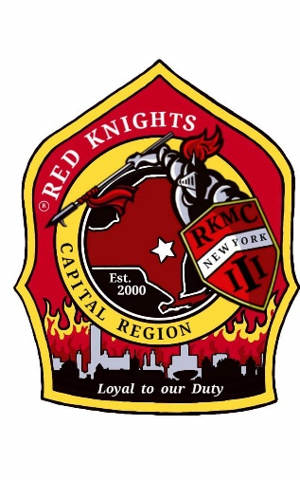
Red Knights
Motorcycle club
New York Chapter III – Capital Region, NY

Date of meeting – May 9, 2024

Place of meeting – NYRVFA (Clubhouse)
- Meeting called to order by President Pat O’Connor at 7:07 pm.
- Pledge of allegiance lead by SAA Ray Hazzard.
- Moment of silence by Pat.
- Prayer by Chaplain Mike Barber.
- Attendance and roll call: 22 members present.

Membership: Tony, Ray, Larry, Mike B. – 1 new application was received. Val Donahue for honorary membership. Sponsored by Tony Vogt. Motion by Kris to accept Val for membership, 2nd by Mary. Motion passed.
- Secretary-Motion made to dispense the reading of the minutes made by Kenny and 2nd by Mike M. Motion Passed.

Secretary Report: – Deb Landy – Thank card from Kris for her gift basket and gift card presented to her at the KSU party. Deb asked the membership if they were ok with the treasurer report to be included in table format. Motion made by Kris to accept the table format, 2nd by Kenny. Motion passed.

Treasurer’s Report: - Jim Alexander –

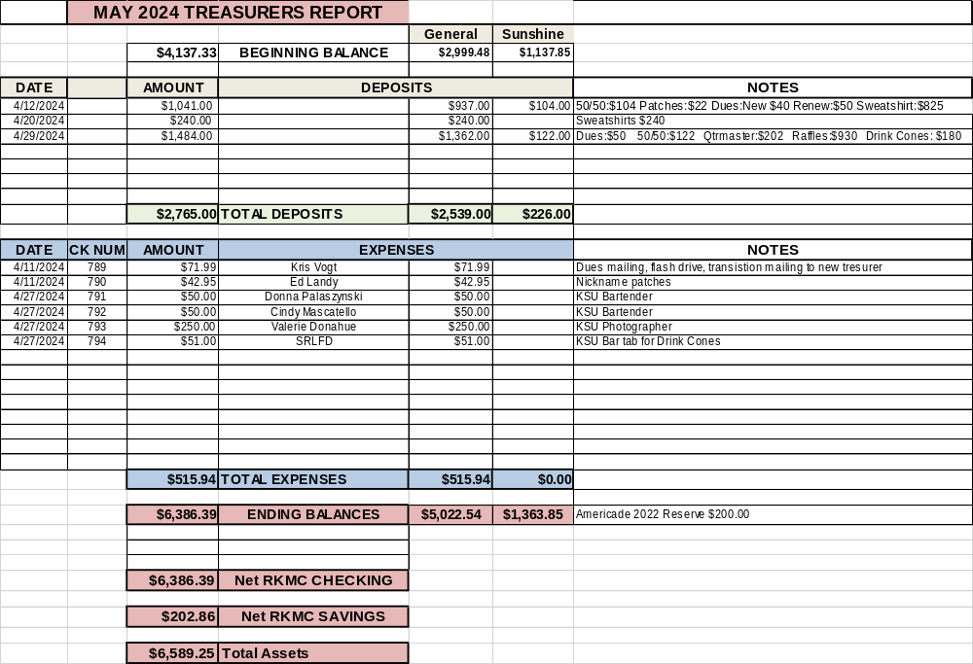

Motion made by Eric to accept the treasurer’s report, 2nd Andrea. Motion passed.

Vice President – Larry Gates – Thank you to Cara, Deb and all of the KSU Committee for a fantastic party.

President Report – Pat O’Connor – Thank you to the entire KSU committee for an incredible party. Thank you to Casey for the amazing table and Deb for the 10 items she made for gifts and raffles. We have some very talented people in our chapter. They make this chapter function and really step up when needed. Pat is proud to be president of this great group.

Appointed Officers:

Chaplain – Michael Barber – no report

Sunshine Club –Deb, Cara, Miranda, and Andrea – 5 cards were sent. Liz Miele got engaged. Justin Higgins is dad to a baby girl. Casey Clemens got metal slivers in his eye. Steve Kuczynski has stage 3 kidney failure. Rick Sweeney tore his bicep. Cards were made for everyone to sign so we can mail them to Eugina Browing as she is home from 2 months in the hospital. Deb presented Jim Alexander with a framed version of the poem she wrote and the prayer by Mike Barber for Doreen’s funeral.

Information Officer– Matt Mickle – Matt spends lots of time working on the web site, creating new pages and in the photo gallery and a Pat Safety Page. Please post any ride and event photos to our Facebook Page so that Matt can put them on the web site. If you want anything posted on the website, get it to Matt. He is always looking for photos of members with their bikes. The web sit is up and running. The password is n3WyorkIII.

Sergeant at Arms: Ray and Mike M. – no report

Quartermaster: Eddie, Jody, Pat, Tony, Nate, Jeaninne –New shirt art idea with S.K.O.F.U. on it has been sent out and should be received soon. It will be forwarded once it is finalized. Sweatshirt order is in. Please pick up your orders. Current stock shirt prices have been decreased. Linda and Jeaninne did inventory of the current stock.

Ride Captain(s): Kevin RC / Don Asst RC – NY 53 bike blessing is meeting at the Hoosick Valley Community Church at 10 am. May 18th is the ride for Veterans celebration in Hoosick Falls and Sunday, May19th is the ride to church. See the ride schedule that was posted on our private page for more upcoming rides.

Committee Reports:

Abate/PAC – Casey – May 20th is the Ride to the Capital. Meet at Stewarts Shop at 1360 Indian Fields Rd, Feura Bus, NY KSU 11:30 SHARP. Be sure your bike is legal, inspected and registered.
Audit and Finance - Don, Larry, Andrea – An audit was done on April 11th. Everything was accurate and correct. Motion to accept the audit made by Mary, 2nd by Rick. Motion passed.

America’s 9/11 Ride – Kevin, Donna, Ernie, Pat, Larry, and Cara – The ride is August 14-18. Registration is open. A flyer has been forwarded to the foundation. Start your fundraising now! Fundraising letters are available. See Kevin or Matt if you plan on going. Some are going to ride to Harrisburg, PA on Wednesday. See Larry if you are going on Wednesday so he can get hotel information out. Mage would like to go and is looking for a back seat. Over $10,000 has been raised so far. A $2,000 donation was made by Charlote DeMarco. www.americas911ride.org

AMERICADE Committee – Don G , Larry, Tony, Calvin C, Ray, Jim, Harold, Kris (food), Matt (Advertising/Artwork) –AMERICADE dates May 28th-June 2nd, 2024. We will continue to host the Wednesday ride. Don has created the route. The ride will start at Lake George Firehouse with lunch at Crown Point. Tony and Kris will be organizing lunch. We will be stopping at Hague Market to say hello, show support and have a group picture. Then back to Fire and Ice in Lake George village. There will be dinner and chapter sales at the firehouse on Thursday.

NON- AMERICADE Committee – Larry, Kevin, Matt, Ray and Kenny – June 11-16,. Larry –Playing with Fire Band is scheduled to play from 6:30 – 9:30 on Saturday. A group BBQ will be planned for Saturday night. Rooms and sites are still available.

Grievance Committee – Ray, Mike M., Deb and Jodi - no report

International Convention Committee – Deb & Eddie - Germany in 2024.

Kick Stands Up Party Committee – Cara, Jeaninne, Pat, Jodi, Tony, Kris, Donna, Mary, Linda, Deb, and Andrea – Well done everyone!! Cara thanked everyone for all their hard work ad Casey for making the clubhouse table. Jim and Sally from Hague Market thanked us for being honored and they donated to the 9/11 ride. Lexi made the trip up after an uncertain week and thanked everyone. Carl and Kathy Smith have not stopped talking about the generosity of NY III. Next year is the Chapter’s 25th Anniversary. There was approximately a $700 profit from the party.

Meeting Room Committee – Cara, Matt, Andrea, and Casey – needs to be cleaned, a date for cleaning detail will be determined at the next meeting.

Memory Tree Committee – Deb, Cara, Jodi, Pat, Donna, and Andrea – no report

Military Committee – Bob & Linda Dennett, Jeannine, Jeff Manor – Jeannine – Great event on May 5ht. Thank you to everyone who helped out and attended. $800 was raised that day and donated to the families who were effective by the helicopter accident at the Mexican border. Linda stated the VA is again looking for food or gift card donations.

Nickname Patch Committee – Pat, Mike B., Eddie, and Deb –Nicknames will be presented at the KSU Party and Rick got his nick name tonight.

NY III Family Picnic – Craig Myers and Kris –This year’s picnic is on August 10, 2024.

Safety Committee: Casey – no report

SOGs - Matt, Mike M, Lori – no report

RITA Walk – “Out of the Darkness” – Linda & Nancy- no report.

YANKEE RALLY 2024 – Deb and Eddie - Hosted by RKMC NH 9 (Keene, NH) and it will be June 5th – 9th. See Facebook Yankee Rally 2024 for details. Registration is $80.00. Some chapter members will be camping.

Ways & Means - Craig, Matt, Bill, Calvin and Casey –Raffle tickets are in and are being distributed. Sell – Sell - Sell

Old Business: none

New Business:

Kris asked for reimbursement of $46.119 hams for the KSU party. Motion to reimburse Kris made by Casey, 2nd by Mary. Motion passed.

Deb presented a receipt for gift card for Kris for $100.00 to be paid to Eddie. Motion to reimburse Eddie made by Mary and 2nd by Andrea. Motion passed.

Deb presented a receipt for chips and dips for the KSU party for $31.37 to be paid to Eddie. Motion to reimburse Eddie made by Matt and 2nd by Liz. Motion passed.

Matt asked to be reimbursed $53 for the raffle tickets. Motion made by Mary to reimburse Matt, 2nd by Kenny. Motion passed.

Kevin asked to be reimbursed $100.44 for the Road Captain award. Motion made by Jimmy to reimburse Kevin, 2nd by Eric. Motion passed.

Check 749 from last year’s raffle is now stale dated and cannot be cashed. Motion made by Jim to add $50 back into the account, 2nd by Matt. Motion passed.

Good and Welfare –

May 19 – Breakfast at Tsatsawassa Fire House. Proceeds are going to America’s 9/11 Ride.

May 21st - 5-9 is the first food truck event in Bloomington. Then the 3rd Tuesday of the month through September.

May 24th – Memorial Day Parade for Maplewood Fire Department. Meet at the firehouse at 5:30.

Village of Menands Centennial Parade - June1st. Pat will distribute details once they are available.

Tunnel to Towers Stair Climb – September 22 – They are looking for volunteers. See Andrea if you would like to volunteer.

50-50 – $45 to chapter and $45 to the winner. Congratulation Jeannine.

Motion to adjourn meeting at 8:40 made by Kenny, 2nd by Andrea. Motion passed.

Website Members Only Password - n3WyorkIII

OUR NEXT MEETING WILL BE THURSDAY, JUNE, 13th AT THE CLUBHOUSE.

