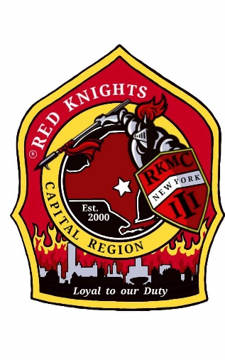
Red Knights
Motorcycle club
New York Chapter III – Capital Region, NY

Date of meeting – July 11, 2024

Place of meeting – Club House, NYRVFA
- Meeting called to order by President Pat O’Connor at 7:05 pm.
- Pledge of allegiance lead by SAA Ray Hazzard.
- Moment of silence by Pat.
- Prayer by Asst. Chaplain Deb Landy.
- Attendance and roll call: 27 members and 1 guest present.

Membership: Tony, Ray, Larry, Mike. – 4 applications received. Barb and Paul O’Kosky for active membership. Motion made by Kenny to wave the background checks as they are former members of NY 12 and Deb vouched for them, 2nd by Cara. Motion passed. Motion to accept Barb and Paul as members made by Eric G., 2nd by Paul K. Motion passed. Keith Marsh for active membership. Tony did the background check. Motion made by Tina to accept Keith, 2nd by Mary. Motion passed. Aaron Jennes for reinstatement of active membership.
Secretary-Motion made to dispense the reading of the minutes made by Kenny and 2nd by Izzy. Motion Passed.

Secretary Report: – Deb Landy – The chapter received a letter from St. Anne’s Institute to support or participate in the Golf Tournament fund raiser.

Treasurer’s Report: - Jim Alexander –

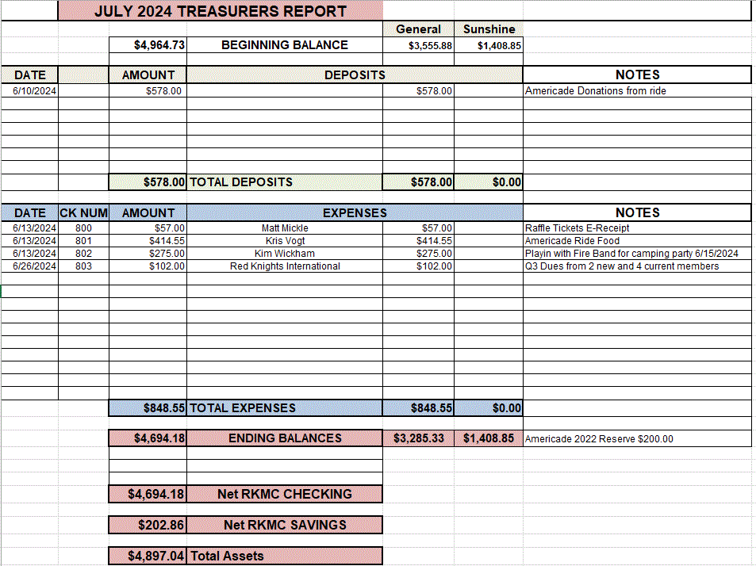

Motion made by Matt to accept the treasurer’s report, 2nd Mary. Motion passed.

Vice President – Larry Gates – no report.

President Report – Pat O’Connor - Summer is going well. Thank you to everyone who sold and bought raffle tickets. This is out main fundraiser. International By Laws changes have been forwarded. Give any feedback to Pat. We would like to see a by law change that allows electronic voting on all issues, by-laws and elections both. Also, do not discuss chapter business or other chapters with people who are not members of our chapter.

Appointed Officers:

Chaplain – Michael Barber (Asst. Deb Landy) – no report

Sunshine Club –Deb, Cara, Miranda, and Andrea – 5 cards were sent. Mark Stark’s mother passed away. Robert Dominquez’s granddaughter passed away. Val Donahue’s cousin passed away. Mike Barber has been in the hospital. Tim Tordoff went into cardiac arrest and spent several days in the hospital. Also, Christine, Mick’s girlfriend had cataract surgery and Bob and Linda’s cat passed away.

Information Officer– Matt Mickle – Matt spends tons of time working on the web site. Please post any ride and event photos to our Facebook Page so that Matt can put them on the web site. If you want anything posted on the website, get it to Matt. He is always looking for photos of members with their bikes. The web site is up and running. The password is n3WyorkIII.

Sergeant at Arms: Ray and Mike M. – no report

Quartermaster: Eddie, Pat, Tony, Nate, Jeaninne, Linda –Orders went in for the S.K.O.F.U. dryfit shirts. Matt ordered the small knight decals. They are $1 each.

Ride Captain(s): Kevin RC / Don Asst RC – Kevin – I apologize for not being at tonight’s meeting. Unfortunately, it is my week to be close in case my mother needs anything. The summer is flying past in a blur it seems and retirement has me traveling almost non-stop, and no that is not a complaint. I highly recommend it to everyone. I hope everyone is getting some quality riding time in and staying safe!
UPCOMING RIDES
- NY 11 POKER RUN – 7/13 @ BACKSTREET BAR & GRILL 35 JOHN STREET HUDSON FALLS
REGISTRATION @ 9AM, KSU @ 10AM (I AM UNAVAILABLE FOR THIS RIDE)

- NY 33 SHOOT & SCOOT - 7/14 @ KNIGHTS OF COLUMBUS 1278 RT 9G HYDE PARK
REGISTRATION @ 9AM, KSU @ 11AM $25 DRIVER, $15 PASSENGER (JUST PASSING ALONG – I HAVE NO PLANS ON ATTENDING)

- NY III GRAND TOUR RIDE – 7/14 – MEET @ STEWART’S 33 FRONTAGE RD GLENMONT
KSU @ 830, LUNCH @ BROOKS BBQ @ APPROX 12, END IN RICHMONDVILLE @ APPROX 430 CONTACT CASEY CLEMENS FOR ADDITIONAL INFO (I AM TENTAIVE FOR THIS RIDE)

- NY 53 VERMONT 100/200 RIDE – 7/20 – 7/21 (OVERNIGHT) CONTACT LISA OR DON McCABE FOR ADDITIONAL INFO (I AM ATTENDING THIS RIDE)

- NY 53 ULSTER COUNTY RIDE – 7/28 @ 9AM - CONTACT JIM WILLIAMS OR DON McCABE FOR MORE INFO (I AM ATTENDING THIS RIDE)

- NY III ANNUAL PICNIC – 8/10 – SEE COMMITTEE FOR MORE INFO

- NY 11 DAY AT THE TRACK - 8/10 - SARATOGA RACETRACK – CONTACT GREG EDDY FOR MORE INFO

- NY 29 RUN TO THE HOME - 8/11 – MORE INFO TO COME (I AM ATTENDING THIS RIDE)

- NY III & 53 – 911 RIDE - 8/14 – 8/18– CONTACT KEVIN KELLER FOR MORE INFO

- NY 53 ANNUAL PICNIC – 8/24 @ 1PM – NASSAU SPORTSMANS CLUB

ALL RIDES WITH MEETING PLACES, TIMES & DETAILS WILL BE POSTED ON THE CHAPTER 3 PUBLIC FB PAGE

7/27 Ryan’s Birthday ride by, meet at Dockstader field (5910 Sacandage Rd, Galway, NY KSU at 1:45pm

7/27 Upstate NY Wounded Vet Run, Brunswick Harley, registration starts at 9am, KSU at noon. $20 per person.

See FaceBook for ride details on all rides.

Committee Reports:

Abate/PAC – Casey – no report.
Audit and Finance - Don, Larry, Andrea – no report.

America’s 9/11 Ride – Kevin, Donna, Ernie, Pat, Larry, and Cara – The ride is August 14-18. Registration is open.
FUNDRAISING IS ONGOING AND WE ARE AT ABOUT $20K – OUR GOAL IS $26K. WE HAVE 17 BIKES AND A TOTAL OF 26 PEOPLE. BLOOMINGTON FD WILL BE SUPPLYING A PICKUP TRUCK AND WILL TOW NY 53’S TRAILER. SELKIRK FD IS TRYING TO GET PERMISSION TO BRING A TRUCK. LARRY GATES FIRE DEPT IS BRINGING A PICKUP TRUCK AS WELL. THERE WILL BE TWO GROUPS LEAVING FOR THE RIDE THIS YEAR. SOME WILL LEAVE WED FOR A SCENIC RIDE THROUGH PA AND OTHERS WILL LEAVE THURSDAY GOING STRAIGHT TO SOMERSET PA. I WILL BE WITH THE WED GROUP.ANY QUESTIONS PLEASE CONTACT ME. www.americas911ride.org

AMERICADE Committee – Don G , Larry, Tony, Calvin C, Ray, Jim, Harold, Kris (food), Matt (Advertising/Artwork) –no report

NON- AMERICADE Committee – Larry, Kevin, Matt, Ray and Kenny – June 11-16. A great time was had by all.

Grievance Committee – Ray, Mike M., Deb and Jodi - no report

International Convention Committee – Deb & Eddie - Germany in 2024.

Kick Stands Up Party Committee – Cara, Jodi, Tony, Kris, Donna, Mary, Deb, Andrea, Kimber, Mick, Linda. Tina and Barb - 25th Silver/Crome Chapter Anniversary. The committee will get together soon to select the date.

Meeting Room Committee – Cara, Matt, Andrea, and Casey – a meeting needs to be scheduled and cleaning needs to be done.

Memory Tree Committee – Deb, Cara, Jodi, Pat, Donna, and Andrea – no report

Military Committee – Bob & Linda Dennett, Jeannine, Jeff Manor – Deb – Pat texted Justin Higgins. He is currently in Qatar and will go to Iraq in October. He does have an APO address that we will forward to the cha There will be another Hometown Heros event in October.

Nickname Patch Committee – Pat, Mike B., Eddie, and Deb –Nicknames submission form is on our website or contact a committee member to submit your suggestion.

NY III Family Picnic – Craig Myers and Kris –This year’s picnic is on August 10, 2024. At noon. 1329 Ridge Rd., Glenville, NY 12302. A sign up sheet went around at the meeting.

Safety Committee: Casey – stay safe.

SOGs - Matt, Mike M, Lori – no report

RITA Walk – “Out of the Darkness” – Linda & Nancy- Sept 22nd.

YANKEE RALLY 2024 – Deb and Eddie – Next year is Bangor, ME. See their FaceBook page for details.

Ways & Means - Craig, Matt, Bill, Calvin and Casey –Both runs of raffle ticktes sold out. $8040 was collected an $3600 will be for prizes. That’s a profit of $4400.

Old Business: none

New Business:

Kris has Americade receipts of $415.55. Motion made by Kenny to reimburse Kris, 2nd by Kenny. Motion passed.

Keith Neitze paid his dues. Motion made by Kris to reinstate Keith, 2nd by Tony. Motion passed.

Craig made a motion the chapter spend up to $250 on paper products, soda and water for the chapter picnic2nd by Don. Motion passed.

Matt made a motion the chapter use the $163 from the Americade ride and add an additional $337 for a total of $500 to America’s 9/11 Ride. 2nd by Morgan. Motion passed.

Nate asked to be reimbursed the balance of the set of fee for the S.K.O.F.U. shirts and the amount Venmo took on some of the payments, not to exceed $20. Motion made by Matt, 2nd by Kris. Motion passed.

Matt asked to be reimbursed $83 for the decals. Motion made by Kris, 2nd by Kenny. Motion passed.

Barb asked for $250 to be donated to her fundraiser for her nephew. The fundraiser is Aug 10th. Motion made by Matt, 2nd by Tina. Motion passed.

Good and Welfare –

July 21 Westmere Auxiliary Brooks BBQ 12-4.

Denis and Don left for PEI on Monday.

8/17 – fundraiser for the son of a friend of the Landy’s that had heart replacement. South Schenectady Fire Department 12-6

Tunnel to Towers Stair Climb – September 22 – They are looking for volunteers. See Andrea if you would like to volunteer.

Tony and Pat have been helping Doc Barry get back on his bike. Doc had an accident many years ago and stopped riding. Tony and Pat too Doc to a parking lot and spend a lot of time with him getting used to riding again. Doc is making progress.

50-50 – $55 to chapter and $55 to the winner. Congratulations Barb O.

Motion to adjourn meeting at 8:44 made by Matt, 2nd by Linda. Motion passed.

Website Members Only Password - n3WyorkIII

OUR NEXT MEETING WILL BE THURSDAY, AUGUST 8TH AT THE CLUBHOUSE.

