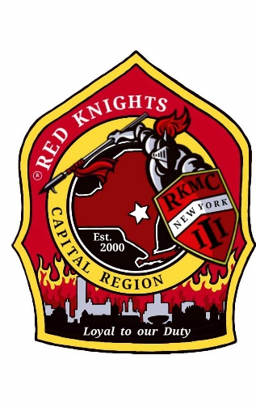
Red Knights
Motorcycle club
New York Chapter III – Capital Region, NY

Date of meeting – August 13, 2026

Place of meeting – Club House, NYRVFA
- Meeting called to order by President Larry Gates at 7:02 pm.
- Pledge of allegiance lead by Ray Hazzard.
- Moment of silence by Larry.
- Prayer by chaplain Deb Landy.
- Attendance and roll call: 27 members and 3 guests.

Attendance: James Alexander, Ismay Ashley, Don Cesare, Casey Clemens, Andrea Clemens, Sean Crowley, Mary Croyle, Kenny Croyle, Bob Dennett, Linder Dennett, Eric Gardner, Donna Garmley, Larry Gates, Nate Goldman, Ray Hazzard, Deb Landy, Mike Mannarino, Matt Mickle, Craig Myers, Pat O’Connor, Paul O’Kosky, Barb O’Kosky, Barb Ritz, Terry Ritz, Cimber Root, Kris Vogt, Tony Vogt

Guests: Howard Stoker, Suzanne Valles, Mike Mongiardo

Membership: -Tony, Ray – Howard Stoker, active membership. Motion made by Pat to accept Howard, 2nd by Izzy. Motion passed. Mike Mongiardo, active membership. Motion made by Donna to accept Mike, 2nd by Kenny. Motion passed. Suzanne Valles, social membership. Motion made by Mike to accept Suzanne, 2nd by Deb. Motion passed.
Secretary – Motion made to dispense the reading of the June minutes as posted made by Barb, 2nd by Linda. Motion passed.
Secretary Report: – Deb Landy – no report.
Treasurer’s Report: - Kevn Keller – as read by Pres. Gates.
General Fund: starting balance is $4,476.08
Income of $8,048.00 (details below)
Income of $8,048.00 – Lottery Ticket Raffle
Expenses of $3,425.00 (details below)
Expense of $75.00 – Matt Mickle (Sword)
Expense of $3,350.00 – Lottery Ticket Winners

Ending Balance for General Fund is $9099.08

Sunshine Fund: starting balance is $1,520.03
Income of $38.00 (50/50)
No Expenses
Ending Balance for Sunshine Fund is $1,558.03
TOTAL CHECKING ACCOUNT BALANCE is $10,657.11

Savings Account: starting balance is $203.15
Income of .02
Ending Balance for Savings Account is $203.17

Motion made to accept treasurer report made by Mary, 2nd by Andrea. Motion passed.

Vice President – Matt Mickle – Roadside Challenge continues. You can use Road Signs or Business Signs. There will be a drawing for a $250 VISA gift card for all who participate in the Road Sign Challenge. Get your photos to Matt

President Report – Larry Gates –Thank you to everyone who rode for Chief Gagnon of the Cottekill FD. When we took the oath of pledge to the chapter we pledge to uphold the constitution of the United States. Larry asks we stand for thee pledge of allegiance and we don’t talk during it. It was asked if standing is part of the US constitution. It is not.

Appointed Officers:

Chaplain – Deb Landy – no report

Information Officer– Matt Mickle – There have been minor issues on the website, mostly on an Apple platform. Be sure to remove old passwords and update them. This might help. If you want anything posted on the website, get it to Matt. He updates the website weekly. The password is on the chapter’s private Facebook page.

Sergeant at Arms: Ray and Mike – no report.

Quartermaster: Nate, Pat, Tony, Jeaninne, Linda – Nate – hats will be ordered, 12 grey and 12 black. Nate will collect the money, they are $30 each. Matt will mock up a new t-shirt with the skull with the III on the back and the knight with a shield on the front.

Ride Captain(s): Pat Road Captain, Don Asst RC, Kevin, Tony – Pat has no new rides to add.

-8/15 – Legion Riders ride from Stillwater Legi9on post.
-America’s 9/11 ride will include some stops for LOYAL TO OUR DUTY patch photos.
-8/29 Cruise for a Cure- Millertown FD
Look on Facebook for upcoming rides.

Committee Reports:

Abate/PAC – Casey – no report.

Audit and Finance - Don, Linda, Kris, Andrea, – no report.

America’s 9/11 Ride – Kevin, Donna, Cara, Matt, Cimber. Marylou, Kenny –This is the 25th Anniversary ride. August 19 – 23, 2026. We will be leaving on Wednesday for Summerset, PA. There is a Red Knights NY team. 21 bikes and 32 people are going. $35,200 raised so far. Safe travels everyone.
AMERICADE Committee – Pat, Kevin, Kris (food), Matt (Advertising/Artwork) - June 2, 2027
NON- AMERICADE Committee – Larry, Cara, Matt, Marylou and Kenny – Next year’s dates – 6/22 – 6/27, 2027. Mark your calendar.

Dixie Rally – 2027 is in Brunswick, GA. 5/13 – 5/16, 2027. See Facebook for details.

Grievance Committee – Ray, Mike, Deb and Jodi – no report

International Convention Committee –Deb and Eddie – Australia, 2026 and cruise for 2027. See Facebook for details.

Kick Stands Up Party Committee – Cara, Kenny, Matt, Barb, Pat – room reserved for 4/17/2027.

Meeting Room Committee – Cara, Matt, Bob, Cimber, Marylou, Kenny –no report.

Memory Tree Committee – Deb, Cara, Donna – no report.

Military Committee – Bob & Linda Dennett, Jeannine, Kimber, Pat – Patrick is back in Hawaii for the time being. Morgan is in Jordan and going on to Kuwait around the end of the month.

Nickname Patch Committee – Pat, Eddie, Tony, and Ray –Nicknames submission form is on our website or contact a committee member to submit your suggestion. One was submitted recently.

NY III Family Picnic – Barb, Pat Izzy, Donna G. – the picnic will be at Craig Meyers’ house, 1329 Ridge Rd. Scotia, NY 12302 on 8-16-26. Sign up sheet is going around.

Safety Committee – Casey, Pat, Kenny –Pay attention to construction. Tis the season.

SOGs - Matt, Mike – There are 2 updates that have been posted that need to be voted on in New Business.

Sunshine Club –Deb, Cara, and Cimber –Gunner, the dog at the Whippoorwill Campground, passed away. Larry and Cara’s dog, Cody, passed away. Pat O’Connor’s brother passed away. Justn Sargalus’ twins are home.

RITA Walk – “Out of the Darkness” – Nancy – 9/26/26 in Schenectady – We will be walking in Schenectady this year. A link has been posted for team Frisky.

YANKEE RALLY 2027 – Larry - 6/9-6/13, 2027, Groton CT. See their Facebook page for details.

Ways & Means - Matt – Ticket sales were fantastic. There were 2 runs of tickets. $8048 sold, $4644 profit. We had a triple winner for the first time. We will do this again in January.

Old Business:

New Business:
SOG 2.10 Logo
Existing SOG

2.10 The Chapter patch is the helmet shield and knight emblem. Alternatively, the knight may be used alone on regalia or other items. When displaying the knight by itself, the knight’s head should be perpendicular to the horizon. The lines on the helmet can be used as reference (reference lines shown). Both images must have the ® registered trademark emblem, having been approved by RKMC International.
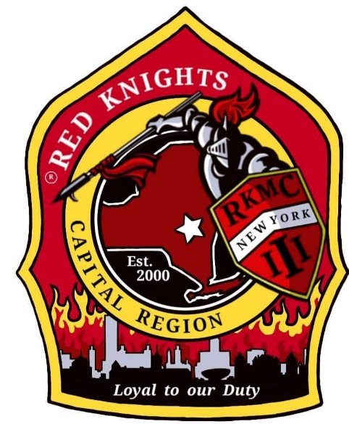
Proposed SOG

2.10 The Chapter patch is the helmet shield and knight emblem. Alternatively, the knight may be used alone on regalia or other items. When displaying the knight by itself, the knight with the upright shield should be used. The knight with the slanted shield shall be grandfathered on any existing items/publications. Both images must have the ® registered trademark emblem, having been approved by RKMC International.
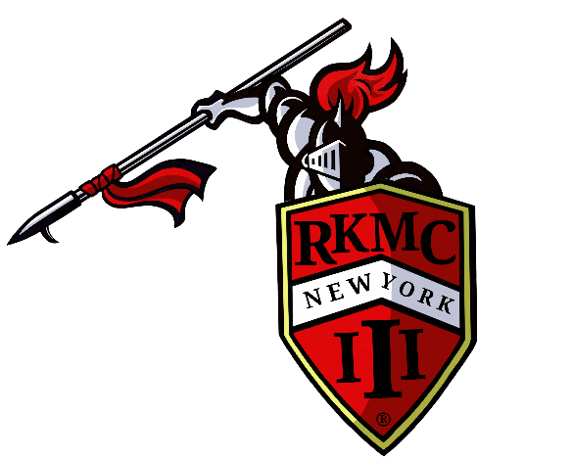
Motion to accept the updated SOG made by Kriss, 2nd by Linda. Motion passed.

SOG 3.14
Existing SOG

3.14 Payment of Dues
a. Prior to the October regular meeting, the Treasurer shall inform the membership, via email with read confirmation, of their upcoming Dues requirement, amount (as defined by Article 3.6), and date of payment (Article 3.14.b). If the Member does not have an email address, a letter will be sent to their home address.
b. Dues payments for the next year should be paid to the Treasurer on or before December 31st. All dues payments collected on or after January 1st shall be assessed a five dollar ($5.00) late fee.

Proposed SOG

3.14 Payment of Dues
a. Prior to the October regular meeting, the Treasurer shall inform the membership, via email with read confirmation, of their upcoming Dues requirement, amount (as defined by Article 3.6), and date of payment (Article 3.14.b). If the Member does not have an email address, a letter will be sent to their home address. This information shall also be posted on the private Facebook page and Members Only section of the website by the Information Officer.
b. Dues payments for the upcoming year should be paid to the Treasurer on or before December 31st. All dues payments collected on or after January 1st shall be assessed a twenty-five dollar ($25.00) late fee.

Motion to accept updated SOG made by Mary, 2nd by Deb. Motion passed.

Kenny made a motion that one must stand for the pledge of allegiance or leave the room for it. 2nd by Paul. Discussion: The decision to stand or sit is up to the individual and is a 1st amendment right. Legally one does not have to stand for the pledge. And as we pledge to uphold the constitution of the United States, we mush honor each individual’s right to choose. We can only ask they do not disrupt the pledge. Motion rescinded.

Nate made a motion to order hats and to not exceed $850. 2nd by Linds. Motion passed.

Good and Welfare –

Kris gave out service certificates and pins to Sean Crawley and Eric Gardner.

8/16 – Benefit fundraiser for Mozie & Bill Ormsby. They are friends of Barb and Paul O’Kosky and were hurt in a motorcycle accident. Schuylerville American Legion, 6 Clancy St, Schuylerville. 1=6 pm.

50-50 – $63 to the chapter and $62 to the winner. Congratulations Jimmy.

Motion to adjourn meeting at 8:17 made by Andrea, 2nd by Linda. Motion passed.

See the chapter private page on Facebook for the Website Members Only Password

OUR NEXT MEETING WILL BE THURSDAY, September 10th AT THE CLUBHOUSE.

