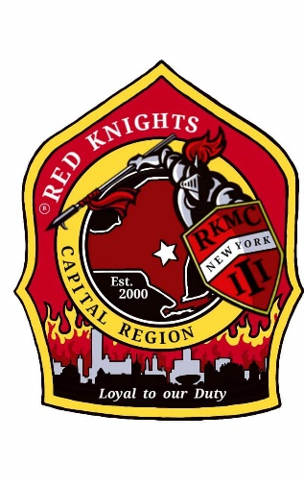
Red Knights
Motorcycle club
New York Chapter III – Capital Region, NY

Date of meeting – October 10, 2024

Place of meeting – Club House, NYRVFA
- Meeting called to order by President Pat O’Connor at 7:11 pm.
- Pledge of allegiance lead by SAA Ray Hazzard.
- Moment of silence by Pat.
- Prayer – no prayer as no chaplain was at the meeting.
- Attendance and roll call: 22 members.

Membership: Tony, Ray, Larry – An application was presented for Patrick Root, social member under Packy Root. Patrick was not present as he is currently serving in the Navy in Hawaii. Motion made by Tony to accept Patrick for social membership, 2nd by Kris. Motion passed. Note – Patrick will pay is initial dues. Future dues will not have to be paid as long as he is actively deployed.

Secretary-Motion made to dispense the reading of the minutes made by Kris and 2nd by Kenny. Motion Passed.
Secretary Report: – Deb Landy – no report. Note – there were no September minutes as there was no September meeting.

Treasurer’s Report: - Jim Alexander –

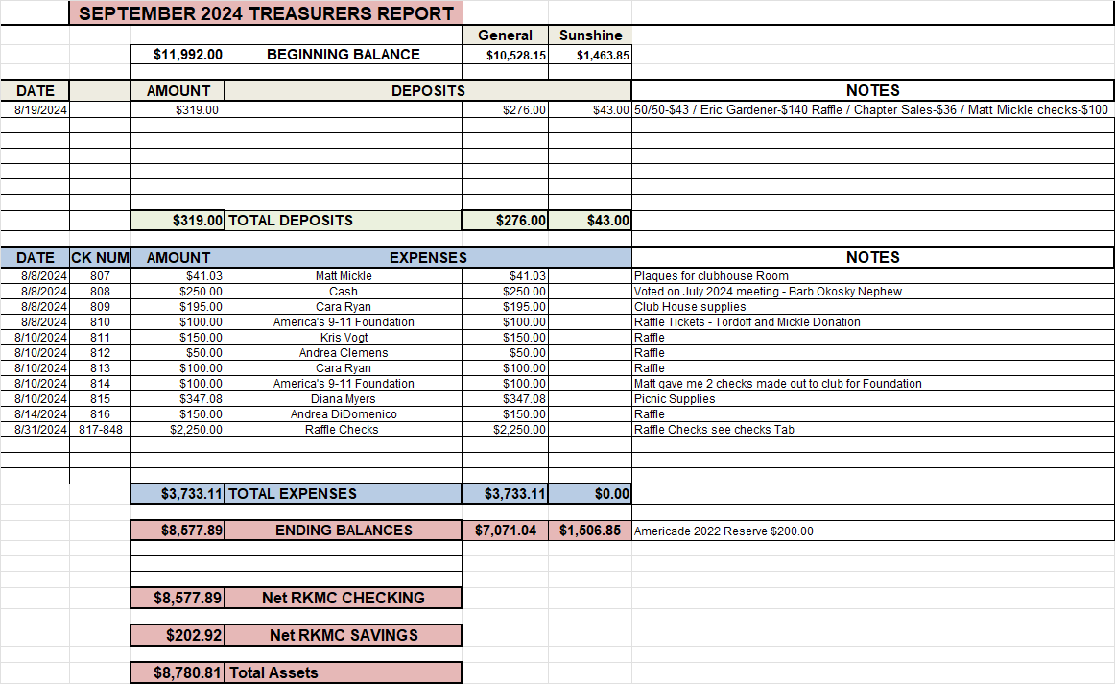

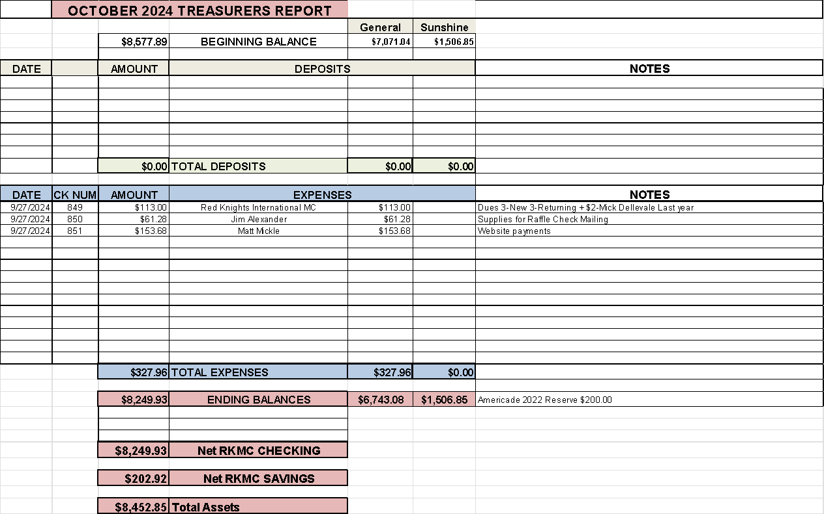
Motion made by Matt to accept the treasurer’s report with the expenses paid, 2nd by Casey. Motion passed.

Vice President – Larry Gates – no report.

President Report – Pat O’Connor –reminder that 3 of the 4 officers were not available in September therefor there was no September meeting. Mike Barber, charter member, past president and chaplain passed away. The chapter did a great job at Mike’s calling hour and funeral. But we do need to remember where we are and not get loud as we so easily can. Vic Post of Ny 53 passed away and again there was a good attendance. Also Dave Plew, Asst. Chief of Brunswick Fire department passed away. Thank you to all who attended the funerals.

NYS Association – Tim Tordoff was elected as president at the September meeting. Tim thanked everyone for going and voting for him. The insurance International signed everyone up for is not valid in NYS. Norm Beausoleil, the International VP, lives in St. Petersburg, FL and has posted he is ok and doing well after the 2 hurricanes. Fran Nestro of NY 11 has been in touch with chapters in NC and is looking into adopting a fire station there. They lost their gear, truck and 2 members. As information becomes available it will be forwarded. Chapter rosters are not always correct. Tim asks that we do everything we can to make sure they are updated and correct. Our members should go to our web site and review their information there and contact an officer if their information is not correct.

Appointed Officers:

Chaplain – Deb Landy – Our charter member, past president and chapter chaplain, Mike Barber passed away. Thank you to all who came to give Mike a proper Red Knights send off. I had lunch with Deb Mainville, Mike's BFF, and she gave me 4 of Mike's RK vests. The vest he most recently wore went to his brother. As Deb M. goes through all of Mike's things, she will give me his shirts and such so they come back to the chapter.
NY 53 member Vic Post passed away. Again, thank you to all who showed up to give Vic a proper send off.
Eddie and I went to the Bootleggers Rally where I gave the Saturday night dinner prayer.
Pat would like another chaplain so the chapter will have two. If you are interested, please let Pat know.

Information Officer– Matt Mickle – Matt spends tons of time working on the web site. He has added 3 more photo galleries. There are tons of photos, check them out. Please post any ride and event photos to our Facebook Page so that Matt can put them on the web site. If you want anything posted on the website, get it to Matt. He is always looking for photos of members with their bikes. Matt discovered that there was another NY 3 that started in the 1980’s and disbanded around 1996. Our current chapter is a sequel. The password for members only is n3WyorkIII.

Sergeant at Arms: Ray and Mike M. – no report

Quartermaster: Nate, Pat, Tony, Eddie, Jeaninne, Linda - members are asking for cold weather gear. This will be brought up in another meeting.

Ride Captain(s): Kevin RC / Don Asst RC Tony Vog– Don–upcoming rides: 10/20 – Brunswick Harley Toys for Tots. 10/24 Fundraiser for Justin Jones of NY 53 who got severely burned. Defreestville Fire Department chicken dinner 4-7 pm. 12/14 –Wreaths Across America.
See Facebook for details.

Committee Reports:

Abate/PAC – Casey – no report.
Audit and Finance - Don, Larry, Andrea – no report.

America’s 9/11 Ride – Kevin, Donna, Ernie, Pat, Larry, and Cara – Over $33,000 was raised for the 2024 ride. Registration for the 2025 ride is open. ww.americas911ride.org

AMERICADE Committee – Don G , Larry, Tony, Calvin C, Ray, Jim, Kris (food), Matt (Advertising/Artwork) –the ride will be Wednesday May 28th, 2025.

NON- AMERICADE Committee – Larry, Kevin, Matt, Ray and Kenny – camping is planned for June 17 – 22, 2025.

Grievance Committee – Ray, Mike M., Deb and Jodi - no report

International Convention Committee –Peoria, Illinois 8/21 – 8/24, 2025 see Facebook for details.

Kick Stands Up Party Committee – Cara, Jodi, Tony, Kris, Donna, Mary, Deb, Andrea, Kimber, Mick, Linda, and Tina. - Kick Stands Up Chrome Edition – Celebrating 25 years of NY III . The date will be April 19, 2025.

Meeting Room Committee – Cara, Matt, Andrea, and Casey - no report.

Memory Tree Committee – Deb, Cara, Jodi, Pat, Donna, and Andrea – Memory Trees will be available in the next couple of weeks and the cost should be around $75.00 Deb will have the details next month.

Military Committee – Bob & Linda Dennett, Jeannine, Kimber – There will be a Hometown Heros Celebration on 10/27 at Central Park Pavilion in Schenectady. There will be Trick or Treating and costumes. Help is requested and welcomed that day. Jeanine would like the chapter to set up a table as we have in the past to collect food and goods for our deployed military. Lisa Oyangen has been discharged for the military and will have to pay dues for next year if she wishes to continue to be a member.

Nickname Patch Committee – Pat,., Eddie, Deb, Tony, and Ray – Nicknames submission form is on our website or contact a committee member to submit your suggestion. A few suggestions have come in. Keep them coming.

NY III Family Picnic – Craig Myers and Kris –This year’s picnic was on August 10, 2024. At noon. 1329 Ridge Rd., Glenville, NY 12302. Good turnout. $400 was raised for America’s 9/11 Ride by throwing Packy in the pool. Everyone had fun. The secretary will send a thank you card to Craig and his family for hosting.

Safety Committee - Casey – watch the road conditions. Leaves are everywhere.

SOGs - Matt, Mike M, Lori – need to amend that active military is to pay their initial dues and will not have to pay as long as they are active.

Sunshine Club –Deb, Cara, Miranda, and Andrea –5 cards were sent. Mike Bager - birth of his daughter. Izzy Ashley - her partner's brother passed away. Rob Wrenn - death of a family friend, a 17 year old girl killed in a car accident. Craig Meyers - made Chief of the year. Barb O'Kosky - 3 extended family members passed away and nephew is in hospital.

RITA Walk – “Out of the Darkness” – Linda & Nancy- Sept 22nd. – no one attended this year, but you can still donate.

YANKEE RALLY 2024 –Kenny – Next year is Bangor, ME . June 4 – 9, 2025. See their FaceBook page for details.

Ways & Means - Craig, Matt, Bill, Calvin and Casey - no report

Old Business: none

New Business:

Kris updated the road captain plaque and asked to be reimbursed $11.61. Motion made by Matt, 2nd by Mary. Motion passed.

Matt made a motion to donate $303.00 to the RITA walk. 2nd by Tony. Motion passed.

Motion made by Kris to spend $100 for candy for the Trunk or Treat. 2nd by Matt. Motion passed. Kris will do the shopping.

Kris made a motion to purchase 20 wreaths at $17 each, $340 total. (For every 2 wreaths we purchase the Patriot Guard will donate another.) 2nd by Frank. Motion passed.

Matt made a motion to donate $200 to Justin Jones of NY 53 who was burned. 2nd by Casey. Motion passed.

Donna made a motion to donate $100 to the ALS foundation in memory of her husband Kevin Koch. 2nd by Tony. Motion passed

Tony made a motion that a blank page be added to the minutes one each for Mike Barber and Vic Post. 2nd by Rick. Motion passed.

Matt made a suggestion of a NY III ride patch. Spell out “New Youk Chapter 3” any firehouse with a 3 on it will work.

Don Gifford has earned the new patch “Loyal To Our Duty” He is one of the first 24 members world wide to earn the parch. Casey has collected his photos and needs to submit the paperwork.

Good and Welfare –
Kris presented Frank Wickham with his 10 year certificate.

Trunk or Treat: 10/19 – North Hoosick Fire Station, 22106 NY-22, Hoosick Falls, 6-8:30 pm. 10/25 – New Lebanon at Walter B Howard Elementary School 1478 US-20, New Lebanon, 6 pm
10/26 – Albany Rural Cemetery, 2 Cemetery Ave, Albany, 4-5:30 pm.

Tony and Kris were in Hawaii for 2 weeks and got to spend time with Patrick Root. They did a tour of a WWII submarine and had dinner with him. It was a very nice visit. Patrick received a citation from a Rear Admiral for outstanding performance.

Tim said that after NY 50’s Squirl ride the group went to Applebee’s. When it came time to pay the bill it had already been paid by an anonymous customer who wanted to thank the group for their service. There were 10 – 12 people at dinner. A very nice gesture.

50-50 – $49 to chapter and $48 to the winner. Congratulations Frank.

Motion to adjourn meeting at 9:05 made by Kenny, 2nd by Morgan. Motion passed.

Website Members Only Password - n3WyorkIII

OUR NEXT MEETING WILL BE THURSDAY, NOVEMBER 14TH AT THE CLUBHOUSE.

This page intentionally left blank in memory of Mike Barber.
Charter Member, Past President, and Chaplin.

This page intentionally left blank in memory of Vic Post of NY 53.

