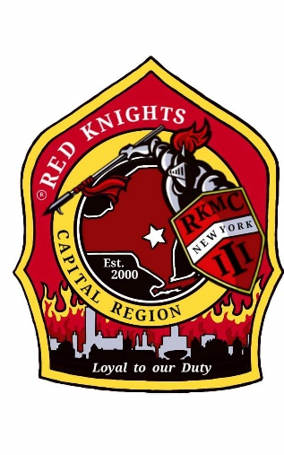
Red Knights
Motorcycle club
New York Chapter III – Capital Region, NY

Date of meeting – December 12, 2024

Place of meeting – Club House, NYRVFA
- Meeting called to order by President Pat O’Connor at 7:06 pm.
- Pledge of allegiance lead by Pat O’Connor.
- Moment of silence by Pat.
- Prayer –prayer by chaplain Deb Landy.
- Attendance and roll call: 28 members.

Membership: Tony, Ray, Larry – no report.

Secretary - Motion made to dispense the reading of the minutes made by Kenny and 2nd by Bob. Motion Passed.
Secretary Report: – Deb Landy – no report.

Treasurer’s Report: - Jim Alexander – Jodi gave the report in Jim’s absence.

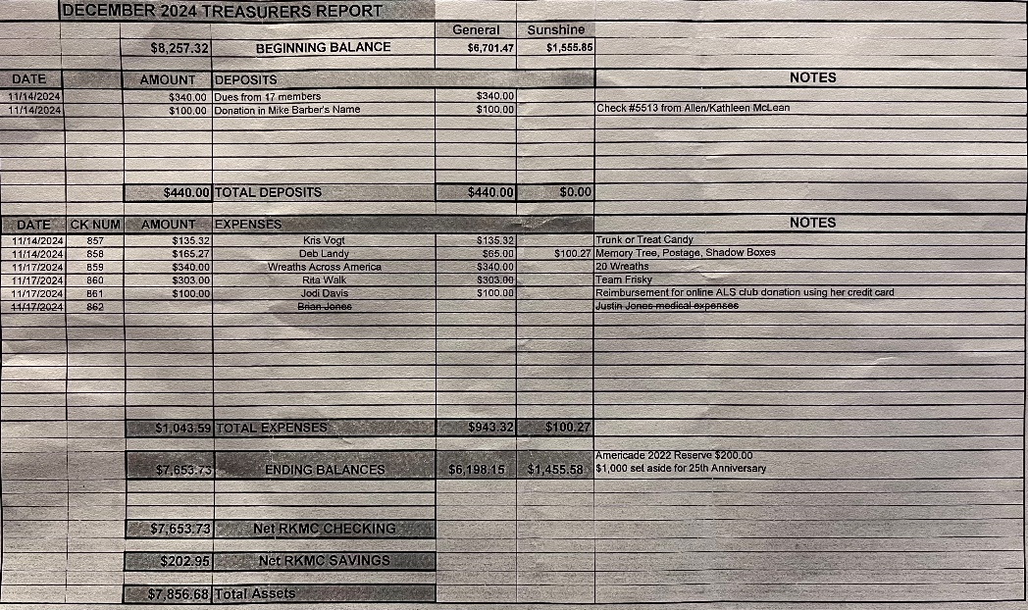

Motion made by Jim T. to accept the treasurer’s report, 2nd by Andrea. Motion passed.

Vice President – Larry Gates – no report.

President Report – Pat O’Connor –Tim and Pat are working on the 1000’s Island overnight trip. They want to do this early in the season, June-ish. Tim and Pat will be going to the NY 25 Christmas party. The NY Association is doing well under Tim’s direction. Thank you to Frank for all he has done. Wreaths Across America is on 12/14, an email was sent out. Andra will stop and pick up breakfast sandwiches. Pat welcomed Patrick Root at NY 53’s meeting, he was on leave and surprised his family and the chapter. Pat hoped everyone had a great Thanksgiving and will have a great holiday season. Please keep everyone in their thoughts this season. If anyone hears of someone who needs help, let the Sunshine committee or an officer know.

Appointed Officers:

Chaplain – Deb Landy – no report

Information Officer– Matt Mickle – Matt spends tons of time working on the web site. He has added more photo galleries. There are tons of photos, check them out. Please post any ride and event photos to our Facebook Page so that Matt can put them on the web site. Matt is working at digitizing the chapter minutes and archiving them on the web site. If you want anything posted on the website, get it to Matt. The price from our hosting service went up 40%. Matt continues to look at another service for a better price. He requires unlimited space as we have tons of stuff.
The password for members only is n3WyorkIII.

Sergeant at Arms: Ray and Mike M. – no report.

Quartermaster: Nate, Pat, Tony, Eddie, Jeaninne, Linda - no report.

Ride Captain(s): Kevin RC / Don Asst RC, Tony – no report.

Committee Reports:

Abate/PAC – Casey – no report.

Audit and Finance - Don, Larry, Andrea – no report.

America’s 9/11 Ride – Kevin, Donna, Ernie, Pat, Larry, and Cara –This is the 25th anniversary of the ride. Registration for the 2025 ride is open. ww.americas911ride.org

AMERICADE Committee – Don G , Larry, Tony, Calvin C, Ray, Jim, Kris (food), Matt (Advertising/Artwork) – Don is looking at ride possibilities. The ride will be Wednesday May 28th, 2025.

NON- AMERICADE Committee – Larry, Matt, Ray and Kenny – camping is planned for June 17 – 22, 2025.

Grievance Committee – Ray, Mike M., Deb and Jodi - no report.

International Convention Committee –Deb and Eddie - Peoria, Illinois 8/21 – 8/24, 2025. See Facebook for details.

Kick Stands Up Party Committee – Cara, Jodi, Tony, Kris, Donna, Mary, Deb, Andrea, Kimber, Mick, Linda, and Tina. - Kick Stands Up Chrome Edition – Celebrating 25 years of NY III . Sub committees need to be formed. Please contact Cara with what you’d like to help with. Go Chrome or Go Home video snippets are on our private page. Invitations will go out in March. The room holds a maximum of 120 people, so it is important that you RSVP.

Meeting Room Committee – Cara, Matt, Andrea, and Casey – There is a new Red Knight statue on the front table. Matt made him.

Memory Tree Committee – Deb, Cara, Jodi, Pat, Donna, and Andrea – The tree was decorated on 12/8 after Santa and Mrs. Pictures. Great showing of chapter support and great job decorating.

Military Committee – Bob & Linda Dennett, Jeannine, Kimber – Linda is willing to do the food donations again. She will deliver nonperishable food or food gift cards that anyone want to bring in. We will be sending care package to Justin Higgins. Matt sent out a list of items. We will use flat rate boxes to sent the items.

Nickname Patch Committee – Pat, Eddie, Deb, Tony, and Ray – Pat has collected the submitted suggestions. Nicknames submission form is on our website or contact a committee member to submit your suggestion. Keep them coming.

NY III Family Picnic – Barb O’Kosty and Kris –2025 picnic will be at Barb O’Kosky’s house.

Safety Committee - Casey – No report.

SOGs - Matt, Mike M, Lori – no report.

Sunshine Club –Deb, Cara, and Andrea –1 card was sent. Donna Koch for taking care of her mom and dad.

RITA Walk – “Out of the Darkness” – Linda & Nancy – no report.

YANKEE RALLY 2024 –Kenny – Next year is Bangor, ME. June 4 – 9, 2025. See their FaceBook page for details.

Ways & Means - Craig, Matt, Bill, Calvin and Casey –50/50 raffle to fund the KSU – Chrome Edition Party. Tickets will be in any day and will be sold until 4/19. $5 each or 5 tickets for $20.

Old Business:

Pat found a receipt for flowers for Mike Barber’s funeral for $112.00. Motion made by Barb to reimburse Pat, 2nd by Kris. Motion passed.

New Business:

Elections –
Vice President – nomination for Larry Gates, Larry accepted. Motion made by Kenny to close the nominations, 2nd by Paul. Motion passed. Motion made by Kris for the secretary to cast one ballot, 2nd by Mike. Motion passed.
Secretary - nomination for Deb Landy, Deb accepted. Motion made by Eddie to close the nominations, 2nd by Linda. Motion passed. Motion made by Kris for the Vice President to cast one ballot, 2nd by Paul. Motion passed.
Road Caption – Nomination for Kevin Keller, Kevin accepted. Nomination for Don Gifford. Don will not run against Kevin, respectfully. Motion to close elections and secretary to cast one made by Kris, 2nd by Barb. Motion passed.
Assistant Road Caption – Pat asked Don Gifford if he would accept the appointment. Don accepted.
Motion to close elections made by Kenny, 2nd by Andrea. Motion passed.

Cara presented a receipt for $229.85 for plates, flatware, table clothes for the KSU Chrome Edition Party. Motion made by Matt to reimburse Cara, 2nd by Linda. Motion passed.

Matt presented a receipt for $79.00 for 50/50 tickets. Motion to reimburse Matt made by Mary, 2nd by Kris. Motion passed.

Good and Welfare –

12/15 – breakfast at Tsatsawassa Fire house. 8-11 am. $12. The third Sunday of the month.

12/14 – NYRVFA Christmas party. 3pm. This is a Toys for Tots drive. Dues for NYRVFA are $25 a year. They will be getting a new fob system. Executive officers will also be getting fobs.

50-50 - $52 to the chapter and $51 to the winner. Congratulations Bob.

Motion to adjourn meeting at 8:16 made by Mike, 2nd by Barb. Motion passed.

Website Members Only Password - n3WyorkIII

OUR NEXT MEETING WILL BE THURSDAY, JANUARY 9TH AT THE CLUBHOUSE.

